C64 Expansion Port Extension Port Side Rev. 0
Module Description

Introduction
The purpose of the C64 Expansion Port Extension is to place an Expansion Port connector at a desired location and connect the actual C64 Expansion Port via a ribbon cable. The maximum length of said ribbon cable is not yet determined. This board is connected to the C64 itself.
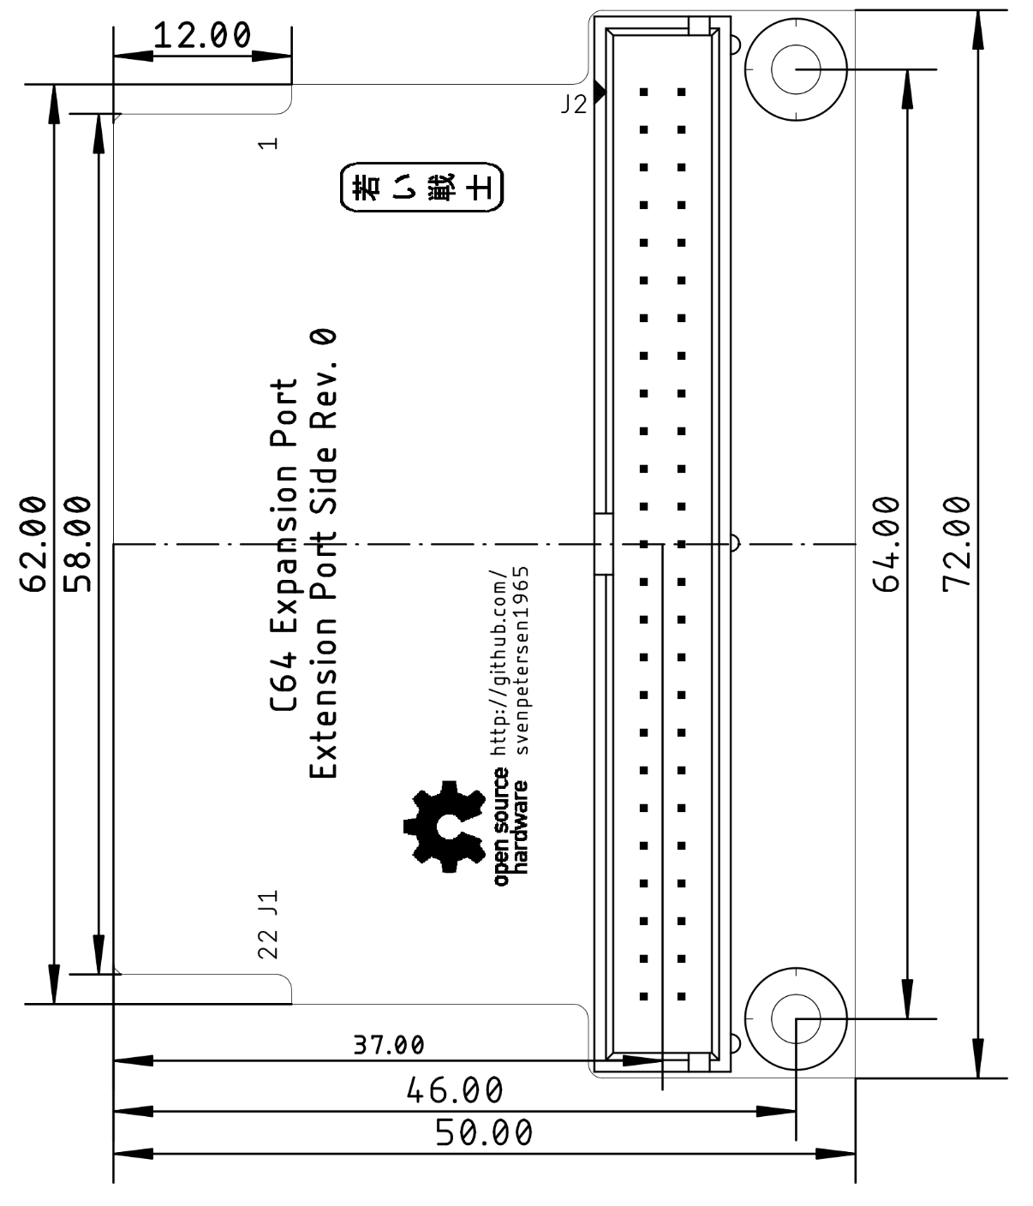
Figure 1: Dimension of the port side PCB

Connector Pinouts

J1 – Expansion Port
Pin (TOP) | Signal | Pin | Signal (BOT)
1 | GND | A | GND
2 | +5V | B | $\overline{ROMH}$
3 | +5V | C | $\overline{RESET}$
4 | $\overline{IRQ}$ | D | $\overline{NMI}$
5 | R /$\overline{W}$ | E | PHI2
6 | DOT CLOCK | F | A15
7 | $\overline{I/O1}$ | H | A14
8 | $\overline{GAME}$ | J | A13
9 | $\overline{EXROM}$ | K | A12
10 | $\overline{I/O2}$ | L | A11
11 | $\overline{ROML}$ | M | A10
12 | BA | N | A9
13 | $\overline{DMA}$ | P | A8
14 | D7 | R | A7
15 | D6 | S | A6
16 | D5 | T | A5
17 | D4 | U | A4
18 | D3 | V | A3
19 | D2 | W | A2
20 | D1 | X | A1
21 | D0 | Y | A0
22 | GND | Z | GND

J2 – Break out connector
2x25 box header, 2.54mm pitch
Pin | Signal | Pin | Signal
1 | GND | 2 | GND
3 | +5V | 4 | GND
5 | +5V | 6 | $\overline{ROMH}$
7 | +5V | 8 | $\overline{RESET}$
9 | $\overline{IRQ}$ | 10 | $\overline{NMI}$
11 | R /$\overline{W}$ | 12 | PHI2
13 | DOT CLOCK | 14 | A15
15 | $\overline{I/O1}$ | 16 | A14
17 | $\overline{GAME}$ | 18 | A13
19 | $\overline{EXROM}$ | 20 | A12
21 | $\overline{I/O2}$ | 22 | A11
23 | $\overline{ROML}$ | 24 | A10
25 | BA | 26 | A9
27 | $\overline{DMA}$ | 28 | A8
29 | D7 | 30 | A7
31 | D6 | 32 | A6
33 | D5 | 34 | A5
35 | D4 | 36 | A4
37 | D3 | 38 | A3
39 | D2 | 40 | A2
41 | D1 | 42 | A1
43 | D0 | 44 | A0
45 | GND | 46 | GND
47 | GND | 48 | GND
49 | GND | 50 | GND

Revision History

Rev. 0
Prototype

